

#### TECHNICAL CONSULTATION PROPOSAL

##### Design, Build & Scale

**Client Info:**

**Name: <<Client Name>>**

**Email: <<Client Email>>**

**Phone: <<Client Number>>**

**Location: <<Country>>**

**Date: <<Date>>**

+12088421478

[info@appsynergies.com](mailto:info@appsynergies.com)

186 Malvern Avenue, Harrow, HA2 9HD, UK AppSynergies Pvt Ltd, D-1602, Orchid Suburbia, Link Road, Kandivali West, Mumbai 400067, India

2

 [www.appsynergies.com](http://www.appsynergies.com/)

Table of Contents

* Company Overview 3
* Our Services 4
* Our Approach 6
* Team Expertise 7
* Business Requirements & Project Overview 8
* Project Pricing 14
* Project Timeline 17
* Client Onboarding 18
* Terms & Conditions 29
* Client Testimonials 20
* Case Studies 21
* Contact Us 22

[info@appsynergies.com](mailto:info@appsynergies.com)

+12088421478

3

 [www.appsynergies.com](http://www.appsynergies.com/)

## COMPANY OVERVIEW



Why Us?

    

|  |  |  |  |  |  |
| --- | --- | --- | --- | --- | --- |
| **100+** | **50+** | **50+** | **100+** | **50+** | **10+** |
| **Projects** | **Apps** | **Websites** | **Happy** | **Technical** | **Years** |
| **Completed** | **Developed** | **Developed** | **Clients** | **Team** | **Experience** |

About Us

Driving Growth Through Technology and Marketing. We help businesses thrive in the digital landscape. From crafting innovative AI-driven apps and websites to executing high-impact SEO, ASO, SMM, content, and email marketing strategies, we deliver measurable results that matter.

We are a fast-growing business with a very talented and rapidly expanding team. We specialize in Design, Development, Testing, Release & Project Management of AI driven apps & websites. We also specialize in Digital Marketing Services like SEO, ASO, SMM, Content & Email Marketing.

Mission

To be a part of people's daily lives by helping them build lasting relationships in an environment of trust & respect.

Vision

To be one of the leading technology & marketing companies in the world, admired for its innovative products & services thereby contributing to a better & sustainable world.

[info@appsynergies.com](mailto:info@appsynergies.com)

+12088421478

4

 [www.appsynergies.com](http://www.appsynergies.com/)

## OUR SERVICES

App Design & Development

At AppSynergies, we build well-designed and optimized custom mobile applications with a delightful UX for both iOS and Android.

 iOS Android

Flutter



 React JS

 Firebase

AI Automations

At AppSynergies, we help you to transform your business with AI & drive growth. Automate repetitive tasks, boost productivity, and make smarter decisions with our powerful AI solutions!

 AI Calling  Chatbots

Make

Automations

GHL

Automations

 ManyChat Automations

[info@appsynergies.com](mailto:info@appsynergies.com)

+12088421478

5

 [www.appsynergies.com](http://www.appsynergies.com/)

Website Design & Development

At AppSynergies, we offer a complete range of website services that build up business value, from the initial idea and formulation of product strategy, through building a prototype and testing it with users, right to the creation of the product itself.



Digital Marketing



Custom Website Design

E-Commerce Development

Responsive Web Design

Content Management System (CMS)

Web Maintenance & Support



We are an AI driven digital marketing agency empowering your business to innovate, optimize & grow in your market using AI-fueled marketing strategies. Our team of experts has over 5 years of experience in the digital marketing industry.

SEO

Social Media Marketing

Content Marketing



 PPC Advertising  Email Marketing Influencer

Marketing

Manual & AI Sales Service



[info@appsynergies.com](mailto:info@appsynergies.com)

+12088421478

6

 [www.appsynergies.com](http://www.appsynergies.com/)

## OUR APPROACH

###### Technical Services

* We begin by researching your industry and audience to create a tailored strategy.
* Our creative team crafts visually stunning and user-friendly apps and websites.
* We offer a complete range of technical services that build up business value.



[info@appsynergies.com](mailto:info@appsynergies.com)

+12088421478

7

 [www.appsynergies.com](http://www.appsynergies.com/)

## TEAM EXPERTISE



Our team comprises of experts in various technical & marketing fields with approximately 5 - 10 years of experience & knowledge in delivering complex projects.

You will have the below list of experienced professionals working on your project:

* Project Manager: <<P1>>
* Business Analyst: <<B1>>
* UI/UX Members: <<U1>>
* Backend Developers: <<BD1>>
* Frontend Developers: <<F1>>
* AI/ML Developers: <<A1>>
* System Architect: <<S1>>
* AWS Developer: <<AD1>>



[info@appsynergies.com](mailto:info@appsynergies.com)

+12088421478

8

 [www.appsynergies.com](http://www.appsynergies.com/)

Business Requirement & Project Overview



**User Registration and Verification:**

1. Account Creation – Users can sign up using their email or social media accounts to access training and resources.
2. Email Verification – A confirmation email is sent to verify the user's identity before granting full access.
3. Secure Login – Users must create strong passwords that meet security standards, with an option for Two-Factor Authentication (2FA).
4. Profile Setup – Users can complete their profiles by adding relevant details such as name, organization, and role in the insurance industry.
5. Chatbot Access Control – Only registered users can access the interactive chatbot for insurance-related inquiries.
6. Forgot Password & Recovery – A "Forgot Password" feature allows users to reset their password via email.
7. User Roles & Permissions – Different access levels (e.g., admin, standard user) can be assigned based on user type.
8. Login Activity Tracking – Users can view their login history to monitor account security and detect unauthorized access.
9. Privacy and Compliance – The registration process adheres to relevant data protection regulations (e.g., GDPR, CCPA).

[info@appsynergies.com](mailto:info@appsynergies.com)

+12088421478

9

 [www.appsynergies.com](http://www.appsynergies.com/)

1. Terms and Conditions Agreement – Users must accept the app’s terms and

conditions before completing registration.

**Modular Architecture**

1. Web-Based Application Focus – The solution will be a web-based app rather than a traditional website, ensuring accessibility and ease of use.
2. Training and Resource Hub – The app will provide structured training materials and resources related to risk analysis in the insurance industry.
3. Specialized Content for Directors & Officers – Content will be tailored to the needs of directors and officers, focusing on insurance risk assessment and compliance.
4. Interactive Chatbot Integration – A chatbot will allow users to ask questions and receive real-time responses about insurance products and policies.
5. Seamless Website Enhancement – The app will integrate with the client’s existing

website, adding functionality without requiring a full redesign.

1. User Authentication & Access Control – Secure user login with role-based access to training materials and chatbot functionalities.
2. Multi-Format Learning Resources – Supports various content types, including text, video tutorials, PDFs, and interactive quizzes for enhanced engagement.
3. Personalized Learning Paths – Users can track their progress and receive recommendations based on their learning history.
4. Real-Time Data & Analytics – Insights into user interactions, chatbot queries, and engagement levels to optimize content and user experience.
5. Compliance & Regulatory Adherence – Ensures all content aligns with relevant insurance regulations and industry standards.
6. Mobile-Responsive Design – Optimized for seamless access across desktops, tablets, and mobile devices.
7. Chatbot Knowledge Base Management – The chatbot’s responses can be updated

and expanded based on evolving insurance policies and user feedback.

1. User Feedback & Support System – Integrated feedback mechanisms to gather user input and improve training content.
2. Integration with Third-Party APIs – Allows future scalability, such as connecting with industry databases or compliance tracking tools.

[info@appsynergies.com](mailto:info@appsynergies.com)

+12088421478

10

[www.appsynergies.com](http://www.appsynergies.com/)

1. Scalable Architecture – Built for future enhancements, enabling the addition of new features without disrupting the core system.

**Web Based App**

1. Training & Resource Hub – The app will provide a comprehensive collection of training materials and resources related to risk analysis in the insurance industry for directors and officers.
2. Interactive Chatbot – A chatbot feature that allows users to ask questions and receive instant, AI-driven answers related to insurance products and risk analysis.
3. Integration with Existing Website – The app will complement and enhance the client’s current website by adding the new functionalities without a full website overhaul.
4. User-Friendly Interface – Simple, intuitive design tailored for directors and officers, ensuring easy navigation through training materials and resources.
5. Account Management – Users can create accounts, manage their profiles, and track their progress in learning modules.
6. Personalized Learning Paths – Based on user preferences or roles, the app can offer customized training plans and courses.
7. Search & Filter Options – Users can easily search for specific topics, risk analysis tools, or insurance products using advanced filtering options.
8. Progress Tracking & Reporting – Users can monitor their learning progress and receive reports on completed modules and quizzes.
9. Multimedia Resources – The app will support various content types, including videos, quizzes, infographics, and downloadable resources, to enhance the learning experience.
10. Real-Time Updates – The app will allow real-time updates to content, ensuring users have access to the latest information on insurance and risk analysis.
11. Mobile Optimization – The app will be fully optimized for mobile devices to allow directors and officers to access training materials on the go.
12. Secure User Authentication – Robust security measures, including strong password requirements and optional two-factor authentication (2FA), to protect user data.
13. Analytics & Insights – The app will provide administrators with insights into user behavior, popular content, and areas where users may need additional training.
14. Feedback Mechanism – Users can provide feedback on the chatbot’s performance

and the overall learning experience, allowing continuous improvement.

1. Support Resources – Dedicated support channels, FAQs, and tutorials available within the app to assist users with any technical issues or questions.

[info@appsynergies.com](mailto:info@appsynergies.com)

+12088421478

11

 [www.appsynergies.com](http://www.appsynergies.com/)

**Admin Panel**

1. User Management – Admins can create, update, and deactivate user accounts for directors, officers, and other stakeholders.
2. Content Management – Admins can manage and upload training resources, articles, and documents related to risk analysis.
3. Chatbot Analytics – Admins can monitor chatbot interactions, view frequently asked questions, and adjust chatbot responses for improved user engagement.
4. Access Control – Different user roles (e.g., admin, moderator) with customizable permissions to control access to various features.
5. Training Progress Tracking – Admins can track user progress in training modules, including completion rates and quiz results.
6. Resource Management – Easily organize and categorize training content and resources for efficient user access.
7. Notifications & Alerts – Admins can send notifications to users about new resources, updates, or training milestones.
8. Performance Reporting – Admins can generate reports on user engagement, chatbot performance, and content usage.
9. Support Ticket Management – Admins can manage and respond to user queries or issues submitted through support tickets.
10. System Settings – Admins can manage system configurations, including chatbot settings, content visibility, and user preferences.

**Integrations**

1. Chatbot Integration – Implement a chatbot that can interact with users, providing real-time answers and assistance related to risk analysis in the insurance industry.
2. Existing Website Enhancement – Integrate the new app’s functionalities with the client's existing website to ensure a seamless user experience without overhauling the site.
3. Learning Management System (LMS) Integration – Integrate a robust LMS to deliver training content such as courses, videos, and resources related to risk analysis.
4. CRM Integration – Connect the application with a CRM system to track user activity, interactions, and feedback for future improvements and user engagement.

[info@appsynergies.com](mailto:info@appsynergies.com)

+12088421478

12

[www.appsynergies.com](http://www.appsynergies.com/)

1. Data Analytics and Reporting Integration – Enable integration with analytics tools to monitor app usage, user engagement, and gather insights for continuous optimization.
2. Payment Gateway Integration – Add the option for users to make payments for premium courses or resources directly within the app, if applicable

**Comprehensive Management and Support System for the Platform**

1. Web-Based Application Development – A dedicated web app for delivering training and resources on risk analysis in the insurance industry for directors and officers.
2. User-Friendly Interface – Intuitive design that allows easy navigation for users to access training materials and resources.
3. Chatbot Integration – A dynamic chatbot feature that provides instant answers to user queries about insurance products.
4. Training Modules – Structured learning modules focusing on risk analysis, insurance products, and industry-specific scenarios.
5. Resource Library – A centralized repository for relevant articles, case studies, and reports related to insurance risk management.
6. User Authentication & Role-Based Access – Secure login and personalized access based on user roles (e.g., directors, officers, admins).
7. Account Dashboard – A personal dashboard for users to track progress in training, completed modules, and upcoming courses.
8. Real-Time Chat Support – Live chat functionality for users to interact with support agents during training sessions.
9. User Feedback & Ratings – Users can rate training modules and provide feedback

on the app’s content and usability.

1. Automated Reminders – Automated notifications and reminders for users about training deadlines, upcoming modules, and certification renewals.
2. Interactive Quizzes & Assessments – Integrated quizzes to assess users' understanding of key concepts in risk analysis and insurance.
3. Multimedia Support – Support for various types of content, including videos, PDFs, and infographics for diverse learning styles.
4. Content Management System (CMS) – An admin panel that allows easy management of content, including training materials, chatbot responses, and resources.
5. Training Progress Tracking – Real-time tracking of individual user progress through different training modules and assessments.

[info@appsynergies.com](mailto:info@appsynergies.com)

+12088421478

13

[www.appsynergies.com](http://www.appsynergies.com/)

1. Interactive Scenarios – Risk analysis scenarios to simulate real-life decision- making situations for directors and officers.
2. Notifications & Alerts – Users can receive alerts for new training material, changes in regulations, or system updates.
3. Integration with Existing Website – Enhancing the existing website with app functionalities, including seamless integration of the chatbot.
4. Customizable Content – Admins can tailor training material and chatbot responses to align with specific needs or changes in the insurance industry.
5. Data Analytics & Reporting – Built-in analytics for tracking user engagement, progress, and overall system performance.
6. User Support Portal – A dedicated section for user guides, FAQs, and troubleshooting to assist users at any stage of training.
7. Mobile Compatibility – Ensure the platform is responsive and accessible on various devices, including smartphones and tablets.
8. Secure Data Management – Encryption and compliance with data protection regulations (GDPR, CCPA) to ensure the security of user data.
9. Session Management – Users can manage their sessions, resume training, and access previously completed materials.
10. Reporting & Certification – Users can generate reports for completed courses, assessments, and certifications in risk analysis.
11. Continuous Updates & Improvements – Regular app updates to introduce new features, improve functionality, and incorporate user feedback.

Note:

In the initial phase we would be designing & prototyping the website/app/admin panel to show a demo of how it the flow will be and with the click of each button, what will be the situations that we would have to handle to ensure ease of use of the platform.

The points mentioned will be taken care of, feedback from the client will be our priority and depending of the feedback, situations & use cases, these features might be changed accordingly.

[info@appsynergies.com](mailto:info@appsynergies.com)

+12088421478

14



 [www.appsynergies.com](http://www.appsynergies.com/)

## PROJECT PRICING

**Design $ 1000 USD**

**Development $ 2000 USD**

**AI/ML Models $ 1000 USD**

**Annual Maintenance $ 400 USD**

This annual maintenance fee covers the charges to make sure the platform is live and always running properly. If there are any live bugs or anything goes wrong with the platform then we will make sure it is fixed and deployed as soon as possible. We also regularly check & run tests on the platform to make sure everything is working fine.

**Additional Features**

**& Enhancements $ 500 USD**

We would be charging this amount for a team (1 BA/PM, 1 UX, 1 Dev, 1 QA) per week (5 days/40 hrs) on project work after the project completion for any ongoing enhancements, features that the client would want after release.

[info@appsynergies.com](mailto:info@appsynergies.com)

+12088421478

15

 [www.appsynergies.com](http://www.appsynergies.com/)

###### Payment Method

**AppSynergies Pvt Ltd accepts the following payment method:**

* Bank Transfer
* Credit Cards and Debit Cards
* Net Banking
* Gpay or Paytm

###### Payment Schedule

|  |  |
| --- | --- |
| **Sr No.** | **Schedule** |
| 1 | Before starting the project, the client needs to pay 30% of the total or the estimated amount. |
| 2 | On 50% project completion, the next 40% payment needs to be released. (After getting UI UX Design Approved) |
| 3 | Once the project gets completed the client needs to pay the rest 30% of the total amount before getting the handover. |

**Note:** We are happy to offer 10% discount if you can sing the contract & start the project withing 48 hours.

Next Steps:

Our proposal is valid for a week. To take advantage of this proposal and proceed with the project as outlined, the client next step must be to:

* Accept the proposal as-is
* Discuss desired changes with AppSynergies Pvt Ltd.
* Finalize and sign the contract
* Submit an initial payment as mentioned in the payment schedule section

Once completed, AppSynergies Pvt Ltd will connect you to schedule project launch meeting to make introductions and gather information before beginning the work.

We are happy to make changes to the project scope on your request at any time but this may be subject to additional billing.

[info@appsynergies.com](mailto:info@appsynergies.com)

+12088421478

16

 [www.appsynergies.com](http://www.appsynergies.com/)

## PROJECT TIMELINE

* 2-3 Weeks  UI/UX Designs
* 3-4 Weeks  Development
* 1 Week  Testing & Live
* Overall Project Completion 2 Months

[info@appsynergies.com](mailto:info@appsynergies.com)

+12088421478

17

 [www.appsynergies.com](http://www.appsynergies.com/)

## CLIENT ONBOARDING



* **Initial Consultation**: We schedule a meeting to discuss your goals, needs, and expectations.
* **Proposal Presentation**: We present our tailored proposal, including pricing and project details.
* **Project Kickoff**: Once you approve the proposal, we initiate the project, assigning a dedicated team.
* **Regular Updates**: We provide regular progress updates and milestones.
* **Project Completion**: Upon project completion, we conduct thorough testing and hand over all deliverables.
* **Ongoing Support**: We offer post-launch support and assistance as needed.

[info@appsynergies.com](mailto:info@appsynergies.com)

+12088421478

18

 [www.appsynergies.com](http://www.appsynergies.com/)

### Terms & Conditions

Once the project fee is paid in full to AppSynergies Pvt Ltd, any elements of text, graphics, photos, contents, trademarks, or other artwork furnished to the client for inclusion in the website are owned by the client. AppSynergies Pvt Ltd assumes the client has permission from the rightful owner to use any code, scripts, data, and reports provided by the client for inclusion in its materials, and will hold harmless, protect, and defend AppSynergies Pvt Ltd from any claim or suit arising from the use of such work.

AppSynergies Pvt Ltd retains the right to display graphics and other web content elements as examples of their work in their portfolio and as content features in other projects. This agreement becomes effective only when signed by the client and AppSynergies Pvt Ltd. Regardless of the place of signing of this agreement, the client agrees that for purposes of venue, this contract was entered into in Mumbai, India and any dispute will be litigated or arbitrated in Mumbai, India.

The agreement in this contract constitutes the sole agreement between the client and AppSynergies Pvt Ltd regarding all items included.

**This proposal shall be valid until 17/02/2025**

**Feel free to reach out to us at** [info@appsynergies.com](mailto:info@appsynergies.com) **or +12088421478 for any questions.**

**Signature Details**

|  |
| --- |
| <<Signature>> |

Sneha Shukla

|  |  |
| --- | --- |
| <<Client Name>> | Sneha Shukla |
| <<Date>> | <<Date>> |

We look forward doing business with you.

Thank You, Team AppSynergies

[info@appsynergies.com](mailto:info@appsynergies.com)

+12088421478

19

 [www.appsynergies.com](http://www.appsynergies.com/)

### Client Testimonials

**Eric**



Sustainability Ledger, CEO

“Very good team with great understanding of apps. They helped me build my idea of energy estimation and management for household. Their development skills are second to none.”

**Benny C**



UCALL, CEO

“Selecting this team proved invaluable. Their professionalism, creativity, and prompt delivery greatly influenced our projects success. We’re grateful for their outstanding dedication!”

**Wai Chan**

My Wallet, CEO

“AppSynergies resolved major issues with the first version of the product, leading to sustained growth for us. Their development skills are second to none!”

**Asim**

Property Dictionary, CEO

“Working with this team was easy and fun. They really know their stuff, and our project turned out way better than we hoped. Looking forward to more projects together!”

**Ankur**

Edlighten, CEO

“They helped us build a psychometric test platform & AI ML Models which helped us analyze the thinking skills of students.”

**Musa**

Hola Home, CEO

“They developed a property booking platform for us. Very fast setup, good team work and handover by their side.”



[info@appsynergies.com](mailto:info@appsynergies.com)

+12088421478

[www.appsynergies.com](http://www.appsynergies.com/)

20

## CASE STUDIES

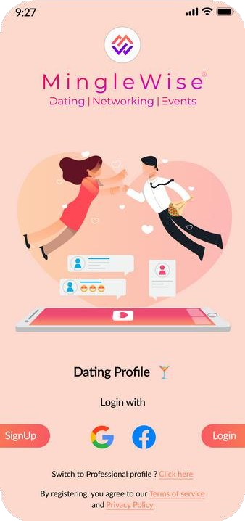

Deliverables

* **Technical Stack**
  + App: Flutter
  + Backend: Node JS,

Firebase

* + Admin Panel: Flutter
* Integrated AI for matchmaking, profile verification,

and event recommendations.

Worlds first all-in-one AI driven app for dating,

networking.



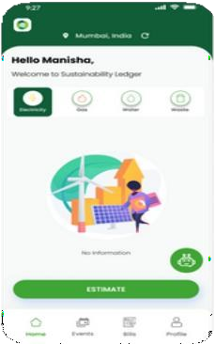

Deliverables

* **Technical Stack**
  + App: Flutter
  + Backend: Firebase
  + Admin Panel: Flutter
* Implemented real-time resource monitoring, analytics, carbon tracking, and community features

with robust data privacy.

Sustainability Ledger is an app that helps household

and small business track their resource usage.

[info@appsynergies.com](mailto:info@appsynergies.com)

+12088421478

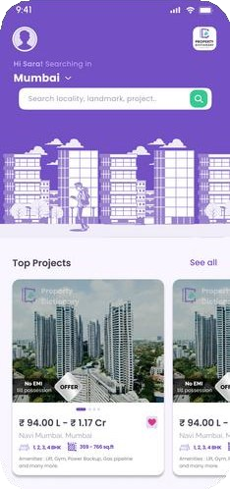

Deliverables

* Technical Stack
  + App: Flutter
  + Backend: Firebase
  + Admin Panel: Flutter
* Developed a property search app with curated listings, advanced filters, virtual tours, direct inquiries, and real-time

notifications.

Property dictionary is your go-to property dictionary app, offering a collection of listings with

comprehensive details.

[www.appsynergies.com](http://www.appsynergies.com/)

21

CASE STUDIES



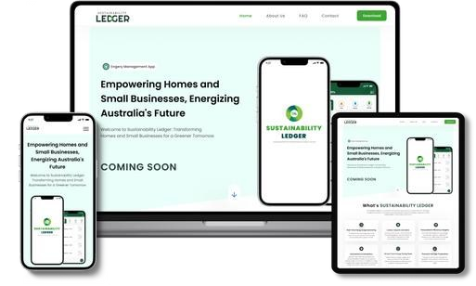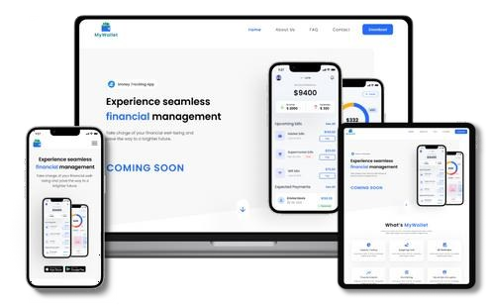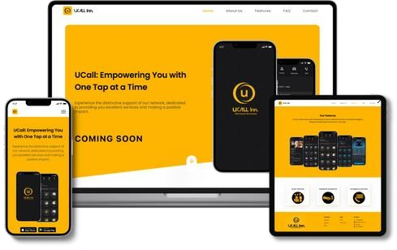

**Revolutionizing homes and small businesses for a more Sustainable tomorrow.**

* Real Time Energy Usage Monitoring
* Carbon Footprint Calculator
* Personalized Efficiency Insights
* Financial Savings Projections

**Take Control of Your Finances with Our Money Tracking App!**

* Expense Tracking
* Budget Management
* Income Analysis
* Financial Report

**Top-notch Services to users and assist in identifying the most fitting job opportunities for you.**

* + Access to Basic Services
  + Roadside Assistance Anywhere
  + Emergency Services at Your Call
  + Book any Service & get rapid response

[info@appsynergies.com](mailto:info@appsynergies.com)

+12088421478

22



 [www.appsynergies.com](http://www.appsynergies.com/)

# Contact Us

**Website** <https://appsynergies.com/>

**Phone** +12088421478

**Email** [info@appsynergies.com](mailto:info@appsynergies.com)

**Social Media**



**Address** 186 Malvern Avenue, Harrow, HA2 9HD, UK. D-1602, Orchid Suburbia, Link Road, Kandivali West, Mumbai 400067, India.



[info@appsynergies.com](mailto:info@appsynergies.com)

+12088421478